2304 – 119 Avenue NE
Edmonton, Alberta
T6S 1B3

April 11, 2026
File No. 4504-1
CANTIRO HOMES LP
700 – 10240 124 Street NW
Edmonton, Alberta
T5N 3W6

Re: Foundation Soils Inspection
Lot 5, 6, 7 & 8, Block 12, Plan 252 2670
2020, 2022, 2024 & 2026 - 212 Street NW
Alces Subdivision
Edmonton, Alberta

As requested, J. R. Paine & Associates Ltd., (JRP), has conducted an inspection of the above noted excavation on April 7, 2026. The purpose of this inspection was to verify that the site soil bearing capacity and expected settlement are adequate to support typical house loads, and where they are not adequate, to recommend a foundation design to address these bearing and settlement issues. It is assumed that this house is designed and will be constructed in accordance with the Alberta Building Code, except where superseded by this letter.
At the time of inspection, the excavation was at footing grade and was advanced by a backhoe. Cuts of approximately 1.6 to 1.9 m below the adjacent ground surface were noted in the house area.
The soil encountered below throughout the excavation floor was identified as moist, brown and grey, silty, sandy clay fill. The clay fill material was of medium plasticity with a very stiff consistency and featured trace amounts of oxides, coal, gravel and organic material. This lot was part of an engineered fill program monitored and tested by our firm.
The soil conditions at this site were considered suitable for the construction of a standard house foundation. A minimum strip footing width of 450 mm and a minimum depth of 150 mm are recommended for this residence. Spread footings may be designed utilizing a factored bearing resistance of 140 kilopascals (2900 pounds per square foot) with a geotechnical resistance factor of 0.5.
A representative sample of soil was gathered from the excavation site and tested to estimate the concentration of soluble soil sulphates present in the soil. The test revealed a negligible concentration of sulphates to be present and based on C.S.A. A23.1-24, Type GU cement may be used for all concrete in contact with the soil.
During cold weather construction, it is essential that all interior fill and load bearing material remain as frost free as possible. In order to minimize the potential frost heave problems, the interior of the building must be heated as soon as the walls have been poured and the sub-floor is placed. The period in which the excavation is left open to freezing conditions should be as short as possible. There must be no delays from the time of excavation to the placement of the temporary heat system. Recommended cold weather construction practices, with respect to hoarding and heating of the forms and the fresh concrete, should be followed.
We trust this information is considered satisfactory. Should you have any questions, please contact our office.

Yours truly,

J. R. PAINE & ASSOCIATES LTD.

Doug Parth, E.I.T.
Reviewed by,

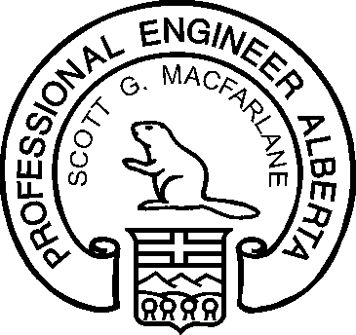

Scott MacFarlane, P.Eng.
APEGA Member #: 89667
/tmp/lo/0000.doc

